

# South Northants Link

Appendix B

**Contents**

1. The route
   1. Northampton Urban Area
   2. Northampton Parkway to Daventry
   3. Daventry to Leamington Spa
   4. Weedon to South Northants Parkway
   5. South Northants Parkway to Banbury
   6. Future extensions
      1. More of the Northampton area
      2. North Northamptonshire
      3. Rugby and Lutterworth
2. Stations
   1. National Rail stop (blue)
   2. Village stop (green)
   3. Town stop (orange)
   4. Street stop (purple)
   5. Misc stop (pink)
3. Services/rolling stock
   1. Service frequency
   2. Rolling stock
   3. Special services
   4. Request stops



# The route

## 1a: Northampton Urban Area

We start in Northampton, where a mini tram network will be formed as part of the light rail version of the South Northants Link in the West of the city.

The stops include:

* Northampton Central
* Stadium
* Sixfields
* Duston
* Duston School
* Harpole
* Kislingbury
* Northampton Parkway

Northampton will be one of the four main hub stations on the network, with the other three being Weedon Interchange, Banbury, and Leamington Spa.

Within the Northampton Urban area, Northampton Central will obviously be the hub station. Let us start there now.

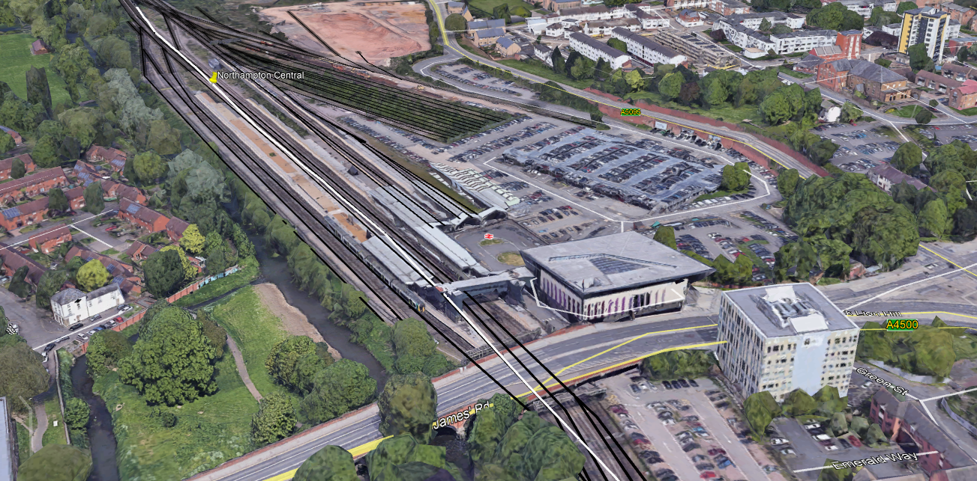

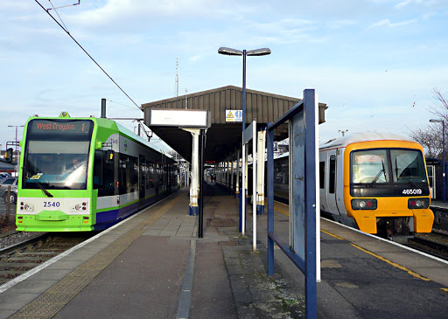Obviously, new light rail platforms will be installed, similar to Wimbledon Central, where heavy and light rail trains are right next to each other.

After 1.7mi from Northampton Central, we arrive at Stadium, the station serving Sixfields football stadium. We expect it to be a relatively busy stop.

After just a few yards from the stadium, the tram network starts its first phase of street running, this time through Sixfields, a retail park. It will also have a stop on the network. This is a relatively long stretch of street running, 1.97mi to be exact, running from the stadium to just west of New Duston. Two stops will exist in Duston, one for the centre of the large village simply called “Duston”, and the other serving The Duston School, a secondary school. This one will be simply named “Duston School” Duston has a population of 15,000, one of the largest population Northampton suburbs.

Street running ends at a mini roundabout just outside Duston and starts its own course on a field instead. The first station after 0.9mi from terminating street running is Harpole, serving the village with the same name, with a population of 1,500.

Now continuing South away from Central Northampton, we arrive at Kislingbury station, of course serving the village of the same name, with a population of 1,200. Just 1.2mi from Kislingbury, we arrive at Northampton Parkway station, serving the Hunsbury Meadows, Northampton Services, and Rothersthorpe areas of Northampton. This is also the last station within Northampton Urban Area.

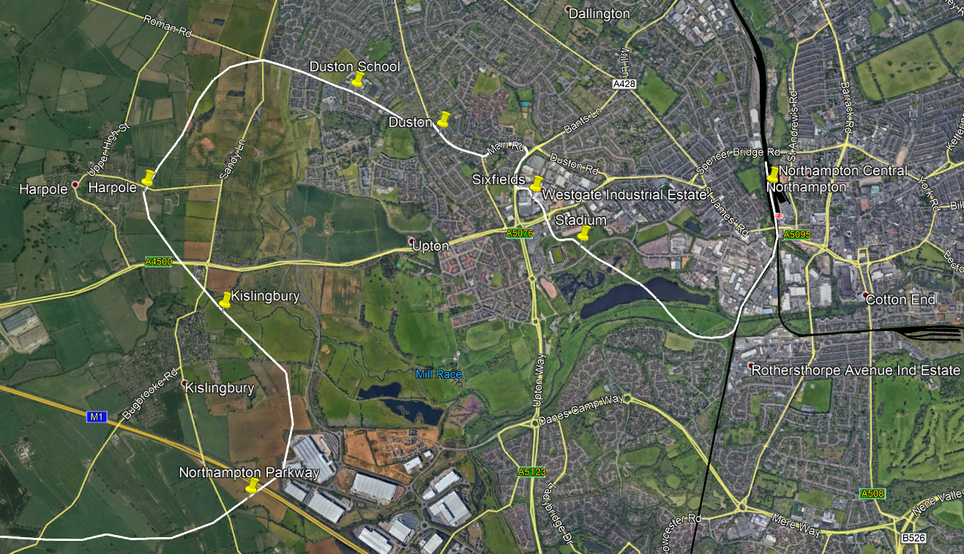

The amount of damage is little to none, and no major damage will occur within the Northampton Urban Area on the route.

## 1b: Northampton Parkway to Daventry

Now moving on to the Daventry District Area of Northamptonshire. We start off at Northampton Parkway, where we ended last time, and start 1.9mi South West to arrive at Bugbrooke station, serving the village of the same name, with a population of 2,700. Next station is Nether Heyford, serving the village of the same name as well, with a population of 1,700.

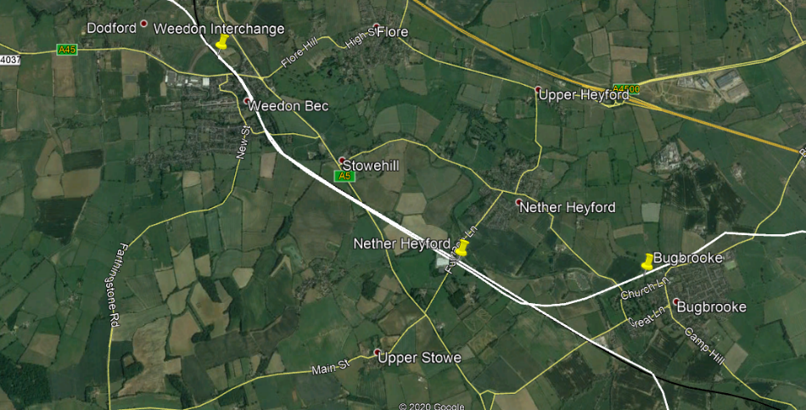2.3mi after Nether Heyford, and 2.3mi after following the side of the West Coast Main Line, we arrive at Weedon Interchange, where eventually National Rail (London Northwestern) services will stop, on their way to places such as London, Birmingham, Stoke-on-Trent, Nuneaton, Milton Keynes, Crewe, and even Liverpool. This will be an easy hub for people in Daventry or Towcester to change onto a heavy rail service. Weedon Interchange of one of 4 hub stations, and also one of 4 National Rail stops on the network.

Now, we are on our way to one of the largest towns in the country without a rail link, and one of the most well-known too, Daventry. It will be served by two stops, but we are not there yet! Now, this is our first old alignment, part of the old Weedon – Marton line, operated by the London and North Western Railway before Beeching closed it during his era.

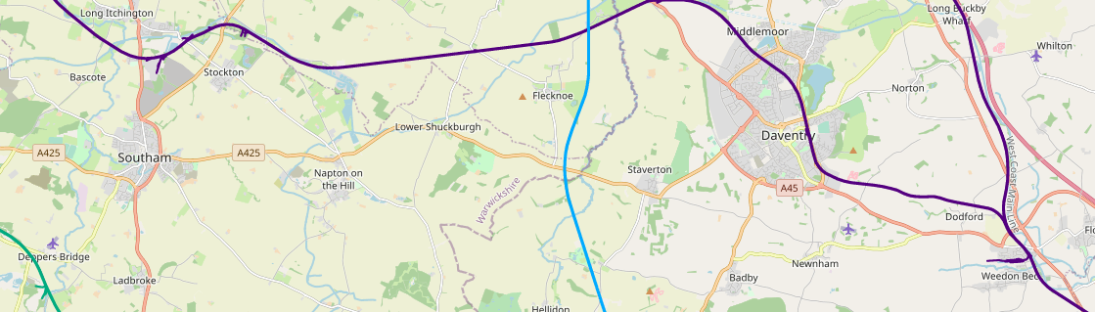

See above, Blue line is the Great Central Main Line (closed), and the purple line across the screen capture is the Weedon – Marton line, with the purple line on the very east of the image being the current West Coast Main Line.

It is 3mi from Weedon to the first stop in Daventry, following the route I have shown above. The first stop in Daventry is Daventry Parkway, just to the South East of the town, near the High March Industrial Estate, which we have to go through. We have two options: 1. Do some street running, or 2. Replace the ground with dedicated tram lines instead.

After 0.77mi from Parkway, we arrive at Daventry’s central station, “Daventry”.

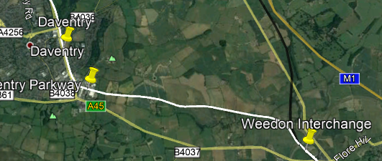

Here is a quick overview of this section:

**Stations**

* Northampton Parkway
* Bugbrooke
* Nether Heyford
* Weedon Interchange
* Daventry Parkway
* Daventry

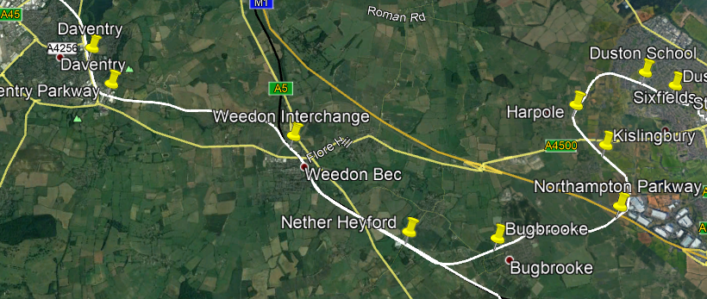

No major damage happens on the route, except possibly High March Industrial Estate. If not, then no major damage will happen on the route.

## 1c: Daventry to Leamington Spa

Now let us continue, this time to Leamington Spa, via Southam. Most of this route is either disused, or currently in operation, such as the West Coast or Chiltern Main Lines.

We leave Daventry going north west, and after 3mi, we are at our first stop, in Braunston. It has a population of around 1,700 people but has major events throughout the year too. It used to be on the Great Central Main Line before Beeching closed it.

One of the largest gaps between stops is coming up, between Braunston and the village of Stockton. We are now in Warwickshire too by the way! Stockton has a population of 1,500 and has a stop on the network. After 1.5mi, we have arrived at Long Itchington, which was the home of Southam’s heavy rail station, of which the town never had a central one, but now, we are going to give it one!

After 2mi, and a bit of street running within Southam, we arrive at Southam’s central and only stop on the network. Southam has a population of 6.5k, and HS2 will run through the outskirts of the town. 3.3mi after Southam’s stop, we arrive at Bishop’s Itchington, a village with around 2,000 inhabitants. It will have a stop on the network.

Around now, we join the Chiltern Main Line, and our last stop before Royal Leamington Spa is Harbury, a village with 2.5k people living in it.

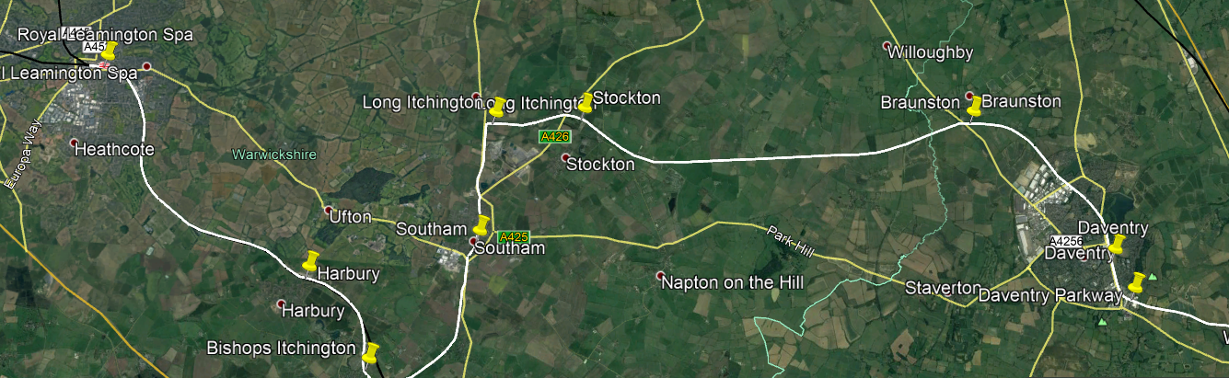

This image sums up this part of the network, and let us give it a bit more of a summing up:

**Stations**

* Daventry
* Braunston
* Stockton
* Long Itchington
* Southam
* Bishops Itchington
* Harbury
* Royal Leamington Spa

Some disused lines will be used on this route, but also following the sides of two different Main Lines

## 1d: Weedon to South Northants Parkway

Quite a simple little section of this branch, Weedon to Towcester. We follow the West Coast Main Line coming out South of Weedon for about 3.4mi, before cutting off and following on our own accord. Our first stop is in Pattishall, a village with a population of 1,400, and many other smaller villages and hamlets around it.

After Pattishall, we follow the A5 for 3.8mi, and arrive in the town of Towcester, a rail-less, and almost bus-less town., with terrible road traffic congestion.

2.4mi after Towcester, we go back up North for 2.4mi to arrive at Greens Norton, with a population of 1,500, many of these go to the local schools in Towcester, or work in Towcester.

Now heading back down South with a tight turn, and a hefty 4.5mi without a stop, we arrive at South Northants Parkway, one of our major stations/stops, serving the Silverstone Circuit, one of the busiest of its kind in the country, the village of Silverstone, and the village of Whittlebury. It serves around 4-6k people combined, not including all the “race-goers” that visit Silverstone.

Now to sum up:

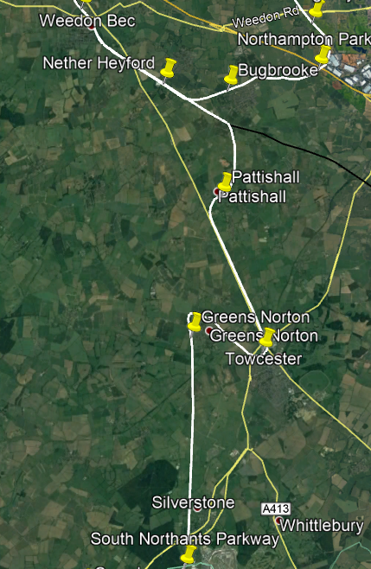**Stations:**

* Weedon Interchange
* Nether Heyford
* Bugbrooke
* Pattishall
* Towcester
* Greens Norton
* South Northants Parkway

No disused lines are used on this part of the route.

## 1e: South Northants Parkway to Banbury

This section may be even simpler. Most of the route follows the A43, and I might not even detail it much. All you need to know is:

* There are stations at:
  + Syresham
  + Brackley
  + Middleton Cheney
  + Banbury
* It crosses the A43 one, and crosses back, so access to Syresham can be made.
* Street running within Brackley, enabling a very central tram stop/station.
* The old Banbury Branch of the LNWR is used from Brackley to Banbury, with a slight cut off to access Middleton Cheney, with a population of 3,500 and bad public transport.

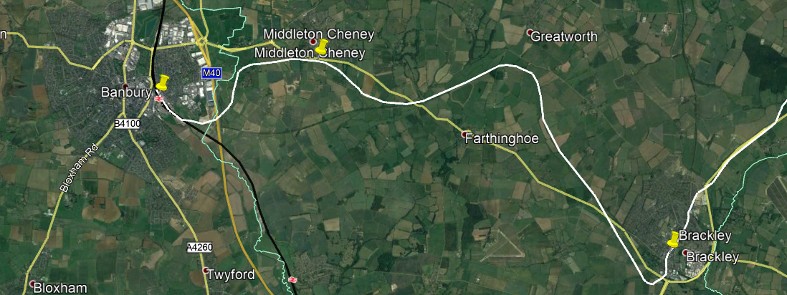

The route is above.

## 1f: Future extensions

Future extensions could happen! Take a look below:

* **More of the Northampton area**
  + Instead of just serving West Northampton, we could also venture out into places such as Moulton, Hardingstone, the Hospital, and Weston Favell.
* **North Northamptonshire**
  + Instead of being stuck in West/South Northants, we could do some connections in North Northamptonshire, where transport is also limited, especially in towns such as Irthlingborough, Rushden, and Thrapston.
* **Rugby and Lutterworth**
  + For two reasons
    - 1. Rugby has a great heavy rail link to not only commuter (LNWR) services, but also Intercity services, such as those operated by Avanti West Coast, surprisingly frequently.
    - 2. Lutterworth have not got a rail link at the moment, and they are a growing town, almost the size of Brackley.



# Stations

## 2a: National Rail stop

In our current plans, 3 existing National Rail stops are on the network, with one proposed.

* Weedon Interchange *proposed*
* Northampton Central *renamed*
* Banbury
* Royal Leamington Spa

In National Rail stops, light and heavy platforms will be right next to each other. An example I like to refer to is Wimbledon tram/train station, with Tramlink services stopping on a platform right opposite a heavy rail platform with Southeastern, South Western Railway, and Thameslink services stopping.



This allows super-efficient and super-fast changes onto heavy rail, especially for places that currently do not have a heavy rail link, do not have a good one (infrequent etc.) or cannot get to the place they want to go from their local station.